**EXPERIMENT NO : 8**

**AIM:** Design appropriate icons pertaining to a given domain.

**THEORY:**

Icons are Pictorial images most often used to represent objects and actions with which users can interact with. Icons can be Stand alone or grouped together in a toolbar. Icons can also be used to represent important information.

Kinds of icons

* **Resemblance:** An image that looks like what it means.
* **Symbolic:** An abstract image representing something.
* **Exemplar:** An image illustrating an example or characteristic of something.
* **Arbitrary:** An image completely arbitrary in appearance whose meaning must be learned.

Characteristics of Icons:

* An icon possesses the technical qualities of syntactic, semantics, and pragmatics.
  + **Syntactic** refers to an icon’s physical structure.
    - Is it square, round, red, green, big, and small?
  + **Semantics** is the icon’s meaning.
    - To what does it refer a file, a wastebasket, or some other object?
  + **Pragmatics** is how the icons are physically produced and depicted.
    - Is the screen resolution sufficient to illustrate the icon clearly?

Influences on Icon Usability

* Provide icons that are:
  + Familiar
  + Clear and understandable
  + Simple
  + Consistent
  + Direct
  + Efficient
* Also consider the:
  + Context in which the icon is used
  + Expectations of users
  + Complexity of task

Size

* Supply in all standard sizes.
  + 16 x 16 pixels
  + 32 x 32 pixels
  + 48 x 48 pixels
* Use colours from the system palette.
  + 16- and 256-color versions
* Minimum sizes for easy selection:
  + With stylus or pen: 15 pixels square
  + With mouse: 20 pixels square
  + With finger: 40 pixels square

Choosing Images

* Use existing icons when available.
* Use images for objects, not actions.
* Use traditional images.
* Consider user cultural and social norms.

Creating Images

* Create familiar and concrete shapes.
* Create visually and conceptually distinct shapes.
* Clearly and simply reflect objects represented, avoiding detail.
* Provide consistency in icon type.

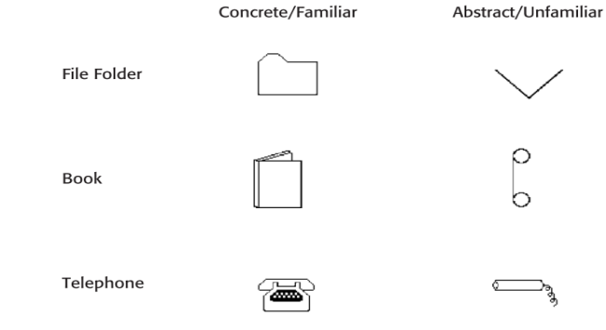 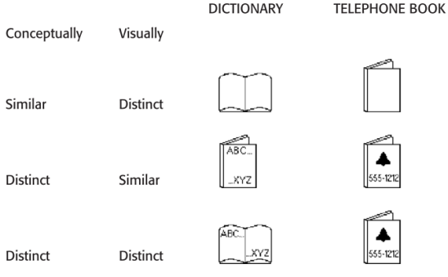

Figure a Figure b

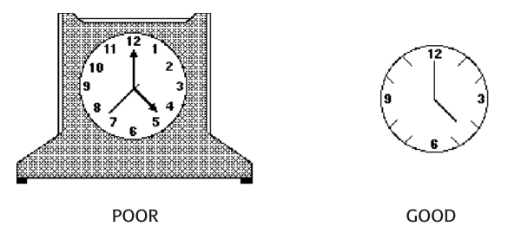 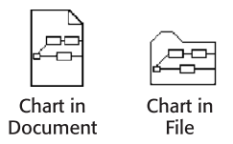 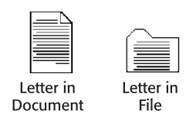

Figure c Figure d Figure e

Icon Animation

* + Use:
    - To provide feedback
    - For visual interest
  + Types:
    - Static(Mail box)
    - Dynamic (Pointer & Movement)
  + Make it interruptible or independent of user’s primary interaction.
  + Do not use it for decoration.
  + Permit it to be turned off by the user.
  + For fluid animation, present images at 16 or more frames per second.

Icon with Audio

* Objects may sound as they touched, dragged, opened, activated and thrown away.
* This provides feedback that an operation one has asked for has successfully started.
* Uses:
  + About previous and possible interactions.
  + Indicating ongoing process and modes.
  + Useful for navigation.

**CONCLUSION:**

Hence we have created icons for _____________ application it possesses following characteristics of icon designing.



|  |  |  |  |  |  |
| --- | --- | --- | --- | --- | --- |
| **Program Execution**  **(7)** | **Documentation**  **(2)** | **Punctuality**  **(2)** | **Viva**  **(4)** | **Experiment**  **Marks**  **(15)** | **Teacher**  **Signature**  **with date** |
|  |  |  |  |  |  |